September 28th, 2008
Hi
Last Sunday evening, 44 people were killed, including 5 from HK, in a blaze and stampede at an illegal nightclub in Shenzhen nightclub. About 1000 people were present. The fire began when fireworks lit inside set fire to the room.
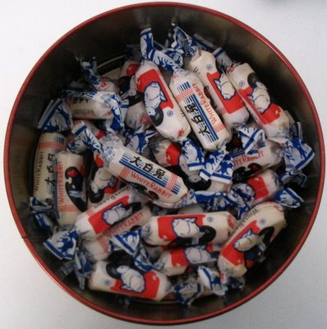
The tainted food saga and its consequences, especially for young children, show no sign of abating. Five children in HK have now been diagnosed with kidney stones. And in China, the number of children affected is now over 53 000, with one report saying there are at least another 10 000. More foods made using tainted milk have been withdrawn from store shelves here, including many popular snack foods and also the popular 'White Rabbit' sweets, which you have probably eaten at one time or other. The Nestle Company also makes products from milk imported from China, including yoghurt. I have consumed this brand of yoghurt almost every day for many years. Last week these were still on the shelves; however, I purchased yoghurt from other countries. In China, the tainted milk problems have spread from humans to Orang-utans, with those that have been raised in captivity and fed milk, now being tested for kidney stones! With the National day holiday on Wednesday (followed by the week-long ‘Golden Week’ holiday, if China still has this), the HK government is worried that large numbers of children born on HK may come back and flood the hospitals from kidney stone tests.
The financial crisis in US financial institutions has spilled over to HK. The Bank of East Asia reported a rogue trader (who reported profits from his dodgy trading instead of his actual massive losses) and immediately there was a ‘run’ on the bank with people withdrawing their savings. People queued overnight outside some BEA branches. However, after assurances that HK banks were sound, the run ended. (The BEA is owned by the Li family; Arthur Li is on its board of directors and his brother is CEO.) I note that Washington Mutual Bank went under and had to be sold. When I arrived in LA in 2003-4, I remember asking you, Leonie and Nadine, what bank I should set up an account with, and you enthusiastically suggested Washington Mutual.
Another typhoon affected HK the other day. The T8 signal was again issued, but only at 6 pm and was lowered early the next morning, so workers did not get an unexpected holiday.

Last Monday, I again injured my lower back - probably carrying a heavy load back from supermarket, which included two heavy bags and a large bag of rice! I say ‘probably’ as there is no sudden pain. The pain only becomes apparent later so I have to guess what the cause might be. I still went to the gym Monday and Tuesday, tough probably shouldn’t have. No exercise on Wednesday. On Thursday and Friday, went swimming without any of the now usual 30-minute aerobics in the gym beforehand. The injury was OK as when swimming, the body is floating and there is no weight exerted on the lower back. Also, just doing swimming again felt strange. Did 2.5 km on Thursday and 3.3 km on Friday.
On Thursday, the broadband icon on my computer indicated a broken connection broken - again! However, the connection was OK again from Friday. However, the technicians still came on Saturday – two hours late – and made a change to the wiring in the wall socket. For them to access the socket I had to move a heavy box of books. I think this made my back injury worse though, again, there was no immediate indication.
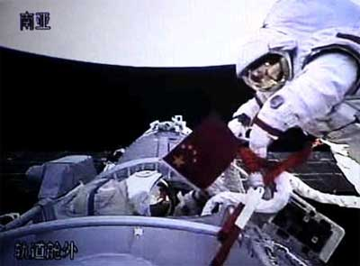
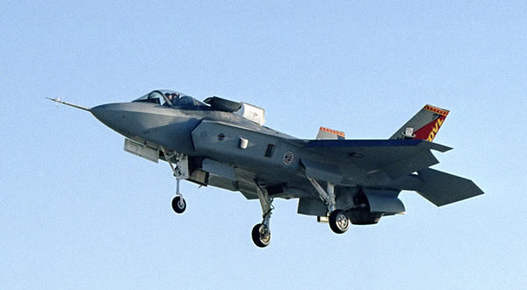
Saw on TV that the aircraft carrier USS George Washington arrived at its base in Japan, amid protests due to it being nuclear-powered. This is the carrier that has replaced the conventi onally-powered USS Kitty Hawk, which I visited several month s ago. As you know probably know, China launched its third manned spacecraft, and one of the three astronauts carried out a brief spacewalk yesterday. Talking about military things, you might be interested, Gavin, that Australia will probably reconsider its order for the new Joint Strike Fighter following a US report that said it is not up to the task and is inferior to its Russian competitors (except for it VTOL capability I suppose). Australia would like the ‘Raptor’ but the US is not exporting these.

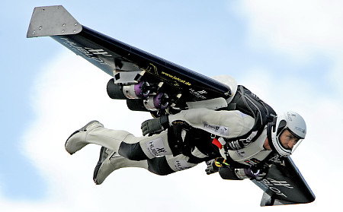
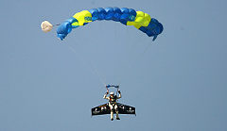
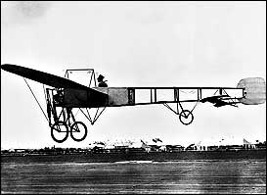
On the TV news last night there was a brief item about Fusion man (aka Rocket man) who had just flown across the English channel. A few minutes later I flicked to the National Geographic channel where, lo and behold, there was a live (or at least ‘delayed live’) report of the flight. It was fantastic! With just short wings and a jet-engine attached to his back, the pilot crossed the channel in 10 minutes. The only flight control he has is through his body movements. He began by jumping from a plane and ended with a parachute descent. He now wants to fin d out how to take off from the ground. The world's first flight over a large body of water in a heavier-than-air craft was by Louis Blériot who crossed the channel in 1909.

In Singapore tonight, the first F1 night race will be held. The circuit is brightly lit and vision is of no concern to the drivers. They are more concerned about the difficulty of overtaking (it is a street circuit) and also the predicted rain which would reflect the light.
October 1st is a public holiday. It is also Nana’s birthday; she would have been 97 years old.

That’s about it for now.
Cheers

